Georgian Shores Minor Hockey Association
Coaching Application 2019-2020
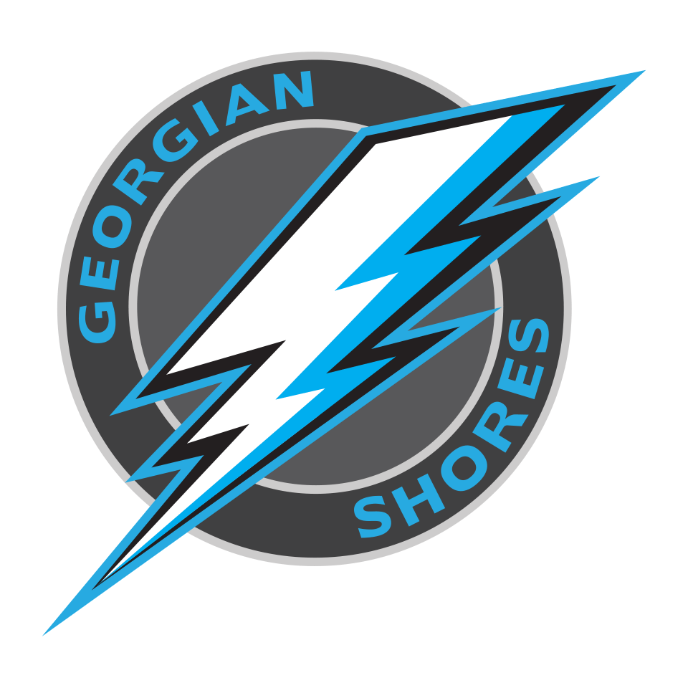

Georgian Shores Minor hockey is now accepting applications for our hockey programs for the 2019-2020 season. If you would like to apply for a position with one of our teams please fill out this application and send it back to jason@georgianshoreshockey.ca. Applications are due June 15, 2019.
All applications are to be typed out to ensure legibility.
Thank you for your application to coach with Georgian Shores Minor Hockey Association, please fill out the following information:
Full Name:
Telephone:
Email:
Address:
Please Indicate the tier you are applying for by checking the box below:
☐ - Rep
☐ - LL
Please Indicate the division you are applying for by checking the box below:
☐ - Preschool/Initiation | ☐ - Peewee
☐ - Tyke | ☐ - Bantam
☐ - Novice | ☒ - Midget
☐ - Atom

Only those being considered will be contacted for an interview.
The coaching selection committee for GSMHA will contact the successful applicants to arrange for an interview. The successful applicant(s) will also be required to submit to a Criminal Background Check, as will all coaching/bench staff selected by the head coach.
Please fill out the following information:
Do you currently have your OMHA Respect in Sport Activity Leader course?
☐ - Yes ☐ - No
Do you currently have your OMHA Gender Identity and Expression course?
☐ - Yes ☐ - No
Do you have your coaching certification appropriate for the team you are applying for?
☐ - Yes ☐ - No
If yes, what level of coaching certification do you have?
Please Specify:
When does your coaching certification expire?
Please Specify:
Do you have an OMHA trainer’s certification?
☐ - Yes ☐ - No ☐ - Expired
When does your trainers certificate expire?
Please Specify:
Would you have a child on the team that you are applying to coach?
☐ - Yes ☐ - No
Has your son/daughter played at a competitive level in previous years?
☐ - Yes ☐ - No
Please begin typing after each question.
- Briefly describe your coaching experience, including the years and divisions you have coached.
- What is your plan to effectively evaluate players at tryouts?
- Briefly, tell us why you want to coach in Georgian Shores and this specific team?
- What is your coaching philosophy and what will be your goals for the team you have chosen?
- How would you define and/or characterize what is a successful team/season?
- What do you consider are your strengths as a coach?
- What areas of your coaching do you feel need improvement?

Please List Three References:
1. Name:
Phone:
Email:
2. Name:
Phone:
Email:
3. Name:
Phone:
Email:

Thank you for your application.

